**Annual Progress Report Template for**

**System Transformation Grant**

**Providing Sector-wide Support**

**January 2022**

**d the Multiplier combined**

|  |
| --- |
|  |

|  |  |  |
| --- | --- | --- |
| **OVERVIEW** | | |
| Country: | | Click to enter text. |
| Name of program this system transformation grant is contributing to: | | Click to enter text. |
| Grant ID (if applicable): | | Click to enter text. |
| Grant agent: | | Click to enter text. |
| Grant effectiveness/start date:[1] | | Click or tap to enter a date. |
| Grant amount: | | Click to enter amount. |
| Timeframe examined in this report (from: month, day, year, to: month, day, year): | | Click to enter text. |
| Date of report submission: | | Click or tap to enter a date. |
| **PURPOSE AND INSTRUCTIONS** | | |
| **Purpose** | | |
| This annual progress report for system transformation grants that provide sector-wide support seeks to:   * Assess and report on the **performance progress and achievements of the grant-supported program for this reporting period**, to inform improvements in the grant’s sector-wide support and financing so as to ensure that its intended aims are fulfilled. * Share **lessons** to improve upon sector-support features and levers of the grant mechanism, and their mobilization. * Ensure **accountability** and **transparency** of the grant and its commitments. | | |
| **Instructions** | | |
| This template is to be completed by the grant agent, after consultation with the government and local education group. As per GPE’s [system transformation grant policy and guidelines](https://www.globalpartnership.org/content/guidelines-education-sector-program-implementation-grants), the grant agent completes an implementation progress report on a yearly basis. The first annual progress report must cover the first 12 months of implementation and must be submitted **no later than 3 months** after the first anniversary of the official grant effectiveness/start date3. The second annual progress report must be submitted no later than 3 months after the second anniversary of the official grant effectiveness/start date. And so forth.  The full report package consists of the following **deliverables**:   * Completed template (present form, including relevant annexes). * Grant Results framework and variable part data (as per the application, or subsequent revisions). * Tangible outputs and knowledge products generated with support from this system transformation grant, or stories of impact * Documentation of the explicit confirmation for variable part targets that have been reached this reporting period, as verified independently by third party. * Annual sector report (can be submitted separately).   Text should be concise and clear. You may add annexes if you wish to only display key text in the report. Overlapping contents may be referenced cross-sectionally to avoid repetitions. It is encouraged to think of the questions as an interdependent whole to build the grant/program story line. Some questions are self-reflective in nature and will necessitate using judgement inferred from triangulated quantitative/qualitative information and logical explanations.  Present evidence and data **disaggregated** by varied subgroups (at a minimum by sex, and by any other groups as feasible). Include a **gender and equity lens** in the narratives, as much as feasible. Evidence and findings should be placed back into the **national/sub-national context** of the country at the time of the review, for better unpacking the information.  The report should be submitted via email to [**gpe_grant_submission@globalpartnership.org**](mailto:gpe_grant_submission@globalpartnership.org)**,** copying the coordinating agency and the GPE Secretariat country team. Following submission, the grant agent may be contacted by the GPE Secretariat for additional information or clarification. The report will be **publicly disclosed** after it is submitted by the grant agent and reviewed by the GPE Secretariat. Please reach out to your GPE Secretariat primary contact in case of questions. | | |
| **LIST OF ACRONYMS** | | |
| Please insert the list of acronyms used in this report, if any.  Click here to add acronyms. | | |
| **I. IMPLEMENTATION PROGRESS** | | |
| **I.1 Overall grant/program progress this reporting period** | | |
| Choose a rating to indicate the **overall level of progress** this reporting period toward achieving the grant/program objective(s) from a technical and financial standpoint, taking into consideration:   1. progress of the individual program objectives, the grant’s variable part, preconditions in place or not for disbursement; 2. level of financial transfer from grant agent to government; 3. level of financial expenditure by government for the program; and; 4. program/grant management performance (i.e. financial management, procurement, monitoring/evaluation, financial reporting requirements, any other compliance requirements). | | ***Overall progress this reporting period***: Select a rating.[2] |
| To explain the progress rating above, please describe briefly:   1. Progress towards **major aims of the grant/program** (while the sector report is expected to report on major accomplishments, this section request reference to highlights that underpin the rating provided). 2. **Progress on financial transfer** from grant agent to government, in comparison to the agreed schedule, and financial **expenditure by government** during this reporting period, (while section II.I request detailed figures, this section requests to report whether or not financial utilization can be considered on track). 3. **Major implementation challenges** or **delays** experienced by the program during this reporting period, as well as any problems with disbursement, absorption, expenditure by government; the **reasons** behind these issues; how they may impact future implementation, how (well) these issues have been mitigated thus far; and what remains to be done by whom and by when to address the major challenges. 4. **Factors** that led to any upgrade/downgrade in the overall progress rating above, compared with the previous reporting period (if any).[3] 5. Whether any progress was made in mitigating **previous reporting periods’ major challenges or delays** (if any). | | |
| Click here to enter text. | | |
| For grants with an overall rating of ‘Moderately Unsatisfactory” or below this reporting period:  Describe major **priority actions planned for the following reporting period** to overcome constraints, build on achievements and partnerships, and use the lessons learned during the reporting period. | | |
| Click here to enter text. | | |
| **I.2 Progress by component** | | |
| Provide in Annex 2 information on the **level of implementation progress for each grant-supported program component** this reporting period. This only applies to grants that have more than one component, for example if technical assistance is provided outside the sector wide mechanism.   * Progress ratings, by component[4] * Brief narrative on key outputs/outcomes achieved per component | | |
| **I.3 Progress on the variable part (if any)** | | |
| If applicable, describe:   1. How well the variable part (VP) **strategies** have been and/or are on track to be implemented and whether **targets** have been and/or are on track to be reached within agreed timelines. 2. How and when **verification** has been conducted for targets (expected to be) achieved during the reporting period.   In addition, please fill in the **VP Reporting Template** in Annex 3. In case of questions, the Secretariat may contact you within 6 weeks after receipt of the template. You may also submit the **Results Framework for the VP**, if there is one.  Lastly, attach **documentation** of the explicit confirmation that VP targets have been reached to allow (partial) disbursement (e.g., independent verification agent’s report, document for validation of results by GA and/or LEG). | | |
| Click here to enter text. | | |
| **I.4 Lessons, innovative/promising practices** | | |
| Indicate any emerging **successful practices**, **innovative interventions** in system-level transformative projects and capacity strengthening, or **lessons**,in relation to the implementation of the grant/program and the grant’s use of country systems during this reporting period. | | |
| Click here to enter text. | | |
| **I.5 Impact stories** | | |
| This reporting period, have you identified any **stories of impact** of the grant/program on: (i) the use of country systems; (ii) beneficiaries and system strengthening; which you would like to share with the GPE Secretariat communications team? If so, provide below or as an attachment. These stories will be featured on GPE communications materials and platforms, with attribution to the provider. | | |
| Click here to enter text. | | |
| **I.6 Tangible outputs and knowledge products** | | |
| Attach the **tangible outputs and knowledge products** (e.g., evaluations, pilots, studies, etc.) generated through the support of the grant. Also, attach any **photos, videos, advocacy posters**, etc. as relevant, that can be showcased in GPE stories or blogs. | | |
| **II. FINANCIAL REPORTING AND GRANT MANAGEMENT PERFORMANCE** | | |
| **II.1 Financial reporting on GPE grant** | | |
| **Cumulative financial absorption rate on GPE grant**  Provide a financial absorption rate based on **cumulative expenditure** expressed as a percentage of the approved grant budget to date and a rating. | ***Approved budget to date***[5]***:*** Click here to enter number. | |
| ***Cumulative expenditure***[6]***:*** Click here to enter number. | |
| ***Cumulative financial absorption rate on GPE grant[7]:*** Click here to enter number. | |
| ***Level of financial absorption of GPE grant9*** ***:*** Select a rating. | |
| If the financial absorption is not rated as On Track, please provide an explanation that identifies the source(s) of the delays and any breakdown of unspent amounts, as well as steps taken to ensure that expenditure absorption gets on track in the next reporting period. | | |
| Click here to enter text. | | |
| **Grant budget variance analysis for the current reporting period** Indicate below: | | |
| (i) Total  approved budget for the current reporting period | (ii) Total expenditure for the current reporting period | (iii) Explanation for underspending or overspending in excess of 10% |
| Click here to enter number. | Click here to enter number. | Click here to enter text. |
| **II.2 Management performance** | | |
| Provide a rating to indicate the management performance during this reporting period. This includes financial, procurement, social/environmental safeguards, implementation arrangements, and other fiduciary management duties. | | ***Level of management performance:*** Select a rating.***[8]*** |
| Explain below how these management arrangements/duties have affected, positively or negatively, the implementation of the grant and its progress toward achieving results/outcomes. Note any management-related issues or shortcomings during the period under review, and how these have been/are being remediated. Why or why not? | | |
| Click here to enter text. | | |
| **II.3 Revisions to the grant** | | |
| ***This reporting period:***  This period, have there been any **revisions[9]** to the grant other than those submitted to the GPE Board or Secretariat for their approval? | ***In the next 12 months:***  How likely is it that the government and grant agent will submit a **request** for revision to the GPE Board or Secretariat in the next 12 months for their approval? | |
| Yes/No. | Select from the list.[10] | |
| If yes, please describe them below. | If ‘Moderately Likely’ or above, please explain below. | |
| Click here to enter text. | Click here to enter text. | |
| **III. MONITORING DATA** | | |
| **III.1 Results framework indicator data** | | |
| If the program application indicated a separate results framework for the grant, provide the complete grant **Results Framework** in a separate annex or as an attachment. The Results Framework should include:   * Milestone, end-target, and baseline indicator values, by objective and component/subcomponent. * Revised target values (if the original target value(s) were formally revised due to restructuring or changes during implementation). * Status on the achievement against target values for the current year. * Reasons for any underachievement//overachievement of indicators this reporting period. | | |
| **III.2 Global numbers data** | | |
| Provide in Annex 4 the data related to GPE’s **three global numbers at program level,** forthisreportingperiod:   * Textbooks purchased and distributed * Teachers trained * Classrooms built or rehabilitated | | |
| **III.3 Beneficiary cumulative children/other students’ data** | | |
| Provide in Annex 5 the cumulative data related to the number of children and other students who **di­­rectly participated in program activities, received program-supported incentives or services, or benefited from program interventions,** so far. If such data is not available, please explain the reasons why in the comment section in Annex 5.  Also provide in the Annex the relevant disaggregated values by subgroups **at a minimum by sex.** If appropriate and available, provide disaggregated values by varied subgroups (children with a disability, refugee children, internally displaced children, out-of-school children, and children from marginalized ethno-cultural/ linguistic minorities) and by education level. | | |

**Annex 1: Decision Trees for Overall Progress Rating and Component/Objective-level Progress Ratings**

**(i) Overall progress rating**

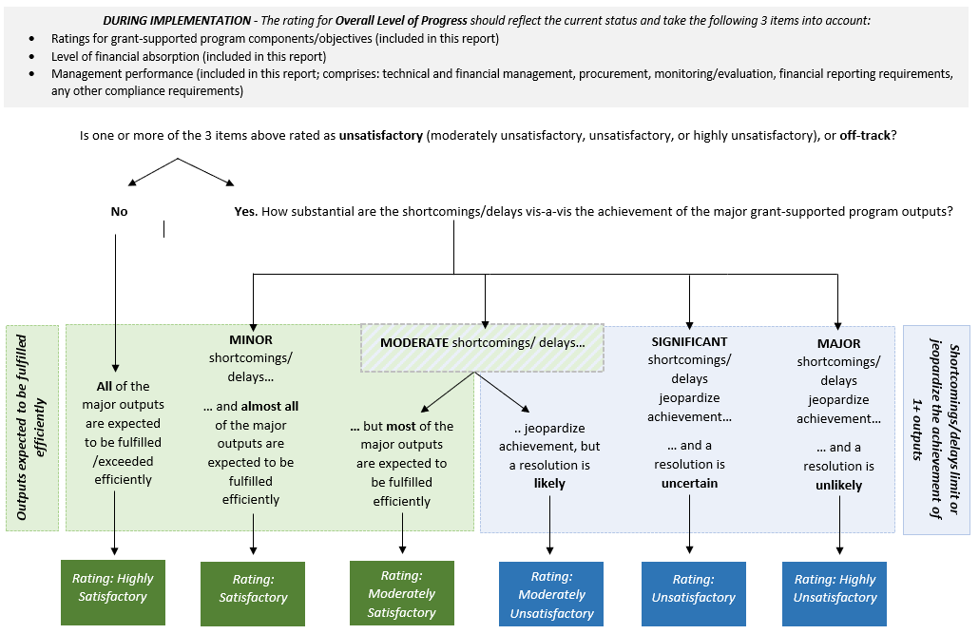

***(ii) Component/objective-level progress ratings***

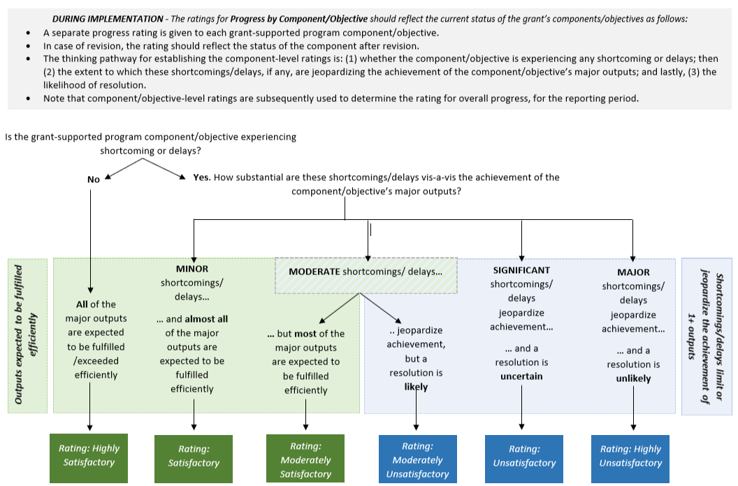

**Annex 2: Implementation Progress, by Grant-supported Program Component/Objective**

|  |  |  |
| --- | --- | --- |
| **Implementation of the components/objectives of the grant-supported program this reporting period** | | |
| Select a rating[11] to assess the **level of progress for each of the grant-supported program components/objectives,** in fulfilling planned outputs during this reporting period, and progress toward achieving planned objectives. | | |
| Component/objective | Level of progress this reporting period: | Brief description of the relative level of success in fulfilling the grant-supported outputs and outcomes planned for this reporting period. Also describe whether the supported objectives are on their way to being fulfilled as planned: |
| Name of component/objective 1: | Select a rating. | Click here to enter text. |
| Name of component/objective 2 : | Select a rating. | Click here to enter text. |
| Name of component/objective 3: | Select a rating. | Click here to enter text. |
| Name of component/objective 4: | Select a rating. | Click here to enter text. |

***(Add or remove components/objectives as needed.)***

**Annex 3: Variable Part Reporting Template (During Implementation)**

|  |  |  |  |  |  |  |  |  |  |
| --- | --- | --- | --- | --- | --- | --- | --- | --- | --- |
| **Reporting period:** from [Month/Year] to [Month/Year] | | | | | | | | | |
| **Indicator** | **Baseline** | **Target for reporting period** | **Achievement for reporting period** | **Disbursement for reporting period** | | **Cumulative disbursement** | | **Evidence of achievements* (e.g., independent verification report) and request for payout \*** please note such evidence in this table and attach relevant documents |
| **Actual amount disbursed**  **(in US$ / €)** | **Proportion (%) of actual amount disbursed to the planned allocation for the reporting period** | **Cumulative amount disbursed**  **(in US$ / €)** | **Proportion (%) of cumulative amount disbursed to the total allocation for the given VP indicator** |
| [ Equity ] Level of progress this reporting period: Select a rating. | | | | | | | | | |
| 1)… |  |  |  |  |  |  |  |  |
| 2)… |  |  |  |  |  |  |  |  |
| 3)… |  |  |  |  |  |  |  |  |
| [ Learning ] Level of progress this reporting period: Select a rating. | | | | | | | | | |
| 1)… |  |  |  |  |  |  |  |  |
| 2)… |  |  |  |  |  |  |  |  |
| 3)… |  |  |  |  |  |  |  |  |
| [ Efficiency ] Level of progress this reporting period: Select a rating. | | | | | | | | | |
| 1)… |  |  |  |  |  |  |  |  |
| 2)… |  |  |  |  |  |  |  |  |
| 3)… |  |  |  |  |  |  |  |  |

***(Add or remove rows as needed.)***

**Annex 4: Global Numbers Reporting Template[12]**

|  |  |  |  |  |
| --- | --- | --- | --- | --- |
| **GPE Indicators** | **Indicator name(s) as in the Program Document and Application Form** | **ACTUAL Number Achieved (during this reporting period)  • Please report the status in numbers, no percentages or ratios**  **• Provide numbers for the entire program. The GPE Secretariat will prorate it in accordance with the proportion of GPE contribution to the entire program amount.** | **% attributed to this grant (for cofinanced grants)** | **Comments** |
| **Textbooks purchased and distributed** | 1)… |  |  |  |
| 2)… |  |  |  |
| 3)… |  |  |  |
| **Teachers trained** | 1)… |  |  |  |
| 2)… |  |  |  |
| 3)… |  |  |  |
| **Classrooms built or rehabilitated** | 1)… |  |  |  |
| 2)… |  |  |  |
| 3)… |  |  |  |

**Annex 5: Beneficiary Children/Other Students Reporting Template**

|  |  |  |  |  |  |  |  |
| --- | --- | --- | --- | --- | --- | --- | --- |
| **Cumulative data on beneficiary children/other students** | | | | | | | |
| Provide the **cumulative** number of children of pre-primary, primary and secondary school age (both in school and out of school) and other students (adolescents beyond secondary school age and adult learners participating in basic education programs), who **directly participated in project activities, received project-supported incentives or services, or benefited from project interventions over the entire duration of the grant. Also provide relevant disaggregated values by sex (applicable to all grants).** If appropriate and available, provide disaggregated values by varied subgroups and by education level. Reporting beneficiary data cumulatively means counting all beneficiaries as a running total, adding up all beneficiaries since the start of the grant. Data on beneficiaries are to be collected using the methods and tools proper to each project. It is understood that some disaggregated data will only be collected if a project expressly targets specific subgroups through their interventions and uses their own methods for counting beneficiary children/other students.[13]  **NOTE:**  For cofinanced grants, please provide the numbers for the entire program and indicate the proportion that can be attributed to GPE grant. For example, if the grant’s financial contribution accounts for 40 percent of the program that is cofinanced by GPE and other donors, enter 40% in the “% attributed to this grant. | | | | | | | |
|  | Pre-primary (optional) | Primary (optional) | Secondary (optional) | Other[14]  (optional) | Total | % attributed to this grant |
| **Number of children/other students who directly benefited from the program this reporting period:** | Enter number | Enter number | Enter number | Enter number | Enter number | Enter number |
| **Of which, female:** | Enter number | Enter number | Enter number | Enter number | Enter number | Enter number |
| Of which, children with a disability (optional): | Enter number | Enter number | Enter number | Enter number | Enter number | Enter number |
| Of which, refugee children (optional): | Enter number | Enter number | Enter number | Enter number | Enter number | Enter number |
| Of which, internally displaced children (optional): | Enter number | Enter number | Enter number | Enter number | Enter number | Enter number |
| Of which, out-of-school children (optional): | Enter number | Enter number | Enter number | Enter number | Enter number | Enter number |
| Of which, children from marginalized ethno-cultural/ linguistic minorities: specify which ones (optional): | Enter number | Enter number | Enter number | Enter number | Enter number | Enter number |
| Provide any comments on beneficiary children, if needed. This could include for example: the definition employed by the program for a particular subgroup (including a more granular description of these subgroups), the approach/tool used to calculate the number of beneficiaries overall or by subgroup, any limitation of the approach/tool employed for this calculation, and reasons why data on beneficiary children is unavailable. | | | | | | | |
| Click here to enter text. | | | | | | | |

1. “Effectiveness” (start) date is considered as the date when the grant implementation has effectively started, marked by the occurrence of an event defined in the grant application.
2. See in **Annex 1** a decision tree to help determine an overall rating for implementation progress. Also, the scale is as follows: ***Highly Unsatisfactory* -** The grant/program has major shortcomings that limit or jeopardize the achievement of one or more program objectives and a resolution is unlikely. ***Unsatisfactory* -** The grant/program has significant shortcomings that limit or jeopardize the achievement of one or more program objectives and a resolution is uncertain. ***Moderately*** ***Unsatisfactory*** - The grant/program has moderate shortcomings that limit or jeopardize the achievement of one or more program objectives but a resolution is likely ***Moderately*** ***Satisfactory*** - The grant/program is expected to achieve most of its major program objectives efficiently with moderate shortcomings. ***Satisfactory*** - The grant/program is expected to achieve almost all of its major program objectives efficiently with only minor shortcomings. ***Highly* *Satisfactory*** - The grant/program is expected to achieve or exceed all of the major program objectives efficiently without significant shortcomings.
3. Factors may include but are not limited to: Program/g**rant management** (management arrangements, roles and responsibilities, etc.). **Grant supervision** (provided supervision during the implementation, including timely and proactive identification of issues and actions taken to address them, etc.). **Factors related to capacity** (institutional and organizational capacities, human resources related capacities and other issues that impact capacity, etc.)**. Financial management/Fiduciary Issues** (adequate procurement, financing, budgeting, and financial management mechanisms in place following the grant agents policies and procedures, etc.). **M&E** (quality of M&E arrangements, including M&E design, implementation, and utilization to inform grant management and decision making; issues related to data availability, etc.)**. Coordination, partnership and participatory processes** (principal grant/program partners, their roles and engagement; information on frequency and reasons for consultations with the local education group during grant implementation, etc.). **External factors, factors beyond implementor/grant agent’s control and unforeseen circumstances** (macroeconomic changes, conflict and instability, natural disasters, changes in government commitment and leadership, issues related to governance and politics, unforeseen technical and logistical difficulties, changes in scope, etc.). **Any other challenges and constraints, and factors** contributing to problems or success in grant implementation.
4. See in **Annex 1** a decision tree to help determine component/objective-level implementation progress ratings.
5. ‘**Approved budget’** refers to the version of the budget that has been approved by the GPE Board (or relevant committee/Secretariat in their delegated authorities) or the revised version of the budget that have been duly approved in accordance with the provisions for revisions specified in the STG policy.
6. ‘**Expenditure’** refers to the amount paid out by implementing partners or grant agents to third parties for services performed or goods delivered. Cumulative expenditure refers to expenditure from grant start date to reporting date. For sector-wide mechanisms, this would normally refer to the actual use by the government of resources after disbursement by the grant agent. This should be complemented by the use of resources for components outside the sector-wide mechanism. It should not include commitments, which refers to the amount that implementing partners or grant agents have an obligation to pay based on signed contracts and following satisfactory contract performance. Agency fee (which is not part of maximum country allocation) should be excluded from cumulative expenditure.
7. Cumulative financial absorption rate can be calculated by using the following formula.
8. ***Highly Unsatisfactory* -** Major shortcomings in performance management can limit or jeopardize the achievement of one or more outputs and a resolution is unlikely. ***Unsatisfactory* -** Significant shortcomings in performance management can limit or jeopardize the achievement of one or more grant outputs and a resolution is uncertain. ***Moderately*** ***Unsatisfactory*** - Moderate shortcomings in performance management can limit or jeopardize the achievement of one or more grant outputs but a resolution is likely. ***Moderately*** ***Satisfactory*** – Performance management is supporting the grant to achieve most of its major outputs efficiently with moderate shortcomings. ***Satisfactory*** – Performance management is supporting the grant to achieve almost all of its major outputs efficiently with only minor shortcomings. ***Highly Satisfactory*** – Performance management is supporting the grant to achieve or exceed all of the major outputs efficiently without significant shortcomings.
9. Revisions to the grant are regulated by the Policy on Education Sector Program Implementation Grants ( <https://www.globalpartnership.org/sites/default/files/document/file/2021-09-gpe-policy-education-sector-program-implementation-grants.pdf>). The policy describes the approval process for different types of revisions. Mentioning a revision in the implementation report doesn’t exonerate from following due process.
10. ***Highly Unlikely*** – A request for revision is extremely unlikely to be submitted to the GPE Board or Secretariat for their approval in the next few 12 months. ***Unlikely*** – A request for revision is unlikely to be submitted to the GPE Board or Secretariat for their approval in the next few 12 months. ***Moderately Unlikely*** – A request for revision is somewhat unlikely to be submitted to the GPE Board or Secretariat for their approval in the next few 12 months. ***Moderately Likely*** – A request for revision is somewhat likely to be submitted to the GPE Board or Secretariat for their approval in the next few 12 months. ***Likely*** – A request for revision is likely to be submitted to the GPE Board or Secretariat for their approval in the next few 12 months. ***Extremely Likely*** – A request for revision is extremely likely to be submitted to the GPE Board or Secretariat for their approval in the next few 12 months.
11. See in **Annex 1** a decision tree to help determine implementation progress ratings at the component/objective level. Also, the scale is as follows: ***Highly Unsatisfactory* -** The component/objective has major shortcomings or delays that limit or jeopardize the achievement of one or more outputs and a resolution is unlikely. ***Unsatisfactory* -** The component/objective has significant shortcomings or delays that limit or jeopardize the achievement of one or more outputs and a resolution is uncertain. ***Moderately*** ***Unsatisfactory*** - The component/objective has moderate shortcomings or delays that limit or jeopardize the achievement of one or more outputs but a resolution is likely. ***Moderately*** ***Satisfactory*** - The component/objective is expected to achieve most of its major outputs efficiently with moderate shortcomings or delays. ***Satisfactory*** – The component/objective is expected to achieve almost all of its major outputs efficiently with only minor shortcomings or delays. ***Highly Satisfactory*** - The component/objective is expected to achieve or exceed all of the major outputs efficiently without significant shortcomings or delays.
12. **General Instructions:**

    1) Starting from FY21, only the actual Global Numbers achieved during a reporting period are required; No Annual targets will be requested onward.

    2) If the STG does not include any or all global number(s), insert ‘not applicable’ in the appropriate text box(es).

    3) If an indicator is measured as a percentage, please provide the **numeric values** that were used to calculate the percentage. If these numbers are not available, please provide the percentage and make a note of it in the comments box

    **GPE's Definitions:**

    **Textbooks purchased and distributed.** This indicator tracks the number of school textbooks that were purchased and distributed through GPE’s STGs during a reporting period. “Textbooks” are books designed for instructing pupils in specific subject areas, including books described as ‘learning material.’ They exclude books in school libraries as well as novels and books for use by teachers (such as curriculum guides, syllabi and teacher guides/kits). In cases where books are designated both as books for use by teachers and as books designed for instructing pupils, the books will be considered textbooks for the purpose of this indicator. The data refer to textbooks that have been “distributed” to schools and have either been distributed to pupils on loan or kept in schools for use in the classroom. The data on textbooks can include textbooks in stock but not currently in use by pupils.

    **Teachers trained.** This indicator tracks the number of teachers who received and completed formal training, according to national standards through GPE’s STGs during the reporting period. “Teachers” comprise professional teaching/instructional personnel who are directly involved in teaching students. They include classroom teachers; special education teachers; and other teachers who work with students as a class in a classroom, in small groups in a resource room, or in one-to-one teaching inside or outside a regular classroom. Teaching/ instructional staff excludes non-professional personnel who support teachers in providing instruction to students, such as teachers’ aides and other paraprofessional personnel. “Training” refers to formal teacher training (pre- or in-service) designed to equip teachers with the knowledge, attitude, behavior, and skills required for teaching at the relevant level and perform their tasks effectively.

    **Classrooms built or rehabilitated.** This indicator tracks the number of classrooms that were built and/or rehabilitated through GPE’s STGs during the reporting period. In the context of this indicator, “Classrooms” comprise rooms in which teaching and learning activities can take place. They are semi-permanent or permanent physical structures and may or may not be located in a school. The term ‘rehabilitated’ may be interpreted differently in different contexts and may be subject to different standards. Therefore, judgement will be exercised to ascertain whether or not a rehabilitated structure (class, school building, etc.) is in accordance with national or other standards that are acceptable and to the satisfaction of the implementing entity. In general, this term means that the structure (class, building, etc.) has been renovated, either fully or partially, implying that the structure is brought up to code.

    **Note:** if the unit of analysis in the indicator is the number of schools and not classrooms, please enter an estimated number of classrooms and provide an explanation in the comments box.
13. Widely accepted definitions of these subgroups are provided for reference only, as we acknowledge that descriptions and criteria for measuring subgroups are context-dependent: **Female**: School-age female children and adolescents, and other students. [**Children with a disability**](https://mcas-proxyweb.mcas.ms/certificate-checker?login=false&originalUrl=http%3A%2F%2Fglossary.uis.unesco.org.mcas.ms%2Fglossary%2Fmap%2Fterms%2F176%3FMcasTsid%3D20892&McasCSRF=3b21de0f0dfefac140b72b5bef4d8cc9e5bb35fb643936b01c98b49e2703e9c6): School-age children with impairments, activity limitations and participation restrictions. Impairment is a problem in body function or structure; an activity limitation is a difficulty encountered by an individual in executing a task or action, while a participation restriction is a problem experienced by an individual in involvement in life situations. [**Refugee**](https://mcas-proxyweb.mcas.ms/certificate-checker?login=false&originalUrl=https%3A%2F%2Fwww.unhcr.org.mcas.ms%2Fwhat-is-a-refugee.html%3FMcasTsid%3D20892&McasCSRF=3b21de0f0dfefac140b72b5bef4d8cc9e5bb35fb643936b01c98b49e2703e9c6) **children**: School-age children who have fled war, violence, conflict or persecution and have crossed an international border to find safety in another country. [**Internally displaced**](https://mcas-proxyweb.mcas.ms/certificate-checker?login=false&originalUrl=https%3A%2F%2Femergency.unhcr.org.mcas.ms%2Fentry%2F250553%2Fidp-definition%3FMcasTsid%3D20892&McasCSRF=3b21de0f0dfefac140b72b5bef4d8cc9e5bb35fb643936b01c98b49e2703e9c6) **children**: School-age children who have been forced or obliged to flee or to leave their homes or places of habitual residence, in particular as a result of or in order to avoid the effects of armed conflict, situations of generalized violence, violations of human rights or natural or human-made disasters, and who have not crossed an internationally recognized state border. [**Out-of-school**](https://mcas-proxyweb.mcas.ms/certificate-checker?login=false&originalUrl=http%3A%2F%2Fglossary.uis.unesco.org.mcas.ms%2Fglossary%2Fen%2Fhome%3FMcasTsid%3D20892&McasCSRF=3b21de0f0dfefac140b72b5bef4d8cc9e5bb35fb643936b01c98b49e2703e9c6) **children**: School-age children who are not enrolled in or attending schools. Out-of-school children encompass both dropouts and children who have never attended school. This second group can either be late entrants or children who will never attend school. **Children from marginalized ethno-cultural/linguistic** [**minorities**](https://mcas-proxyweb.mcas.ms/certificate-checker?login=false&originalUrl=https%3A%2F%2Fwww.ohchr.org.mcas.ms%2FEN%2FIssues%2FMinorities%2FPages%2Finternationallaw.aspx%3FMcasTsid%3D20892&McasCSRF=3b21de0f0dfefac140b72b5bef4d8cc9e5bb35fb643936b01c98b49e2703e9c6): School-age children from a group numerically inferior to the rest of the population of a state, in a nondominant position, whose members—being nationals of the state—possess linguistic characteristics differing from those of the rest of the population; from a group numerically inferior to the rest of the population of a state, in a nondominant position, whose members—being nationals of the state—possess ethnic characteristics differing from those of the rest of the population. 
14. Other includes students beyond the school age of pre-primary through secondary that are not already included (out-of-school adolescents and adult learners participating in nonformal education).